Name: Class:
Introduction
Ethene is the leading synthetic organic chemical in terms of scale of production. Its ease of production, chemical reactivity and versatility make it well suited as the starting molecule for further syntheses. Most ethene is used to make polymers, while some is used to make ethanol, fibres and antifreeze. Since ethene does not occur naturally to any significant extent, it must be produced from hydrocarbons that are derived from natural gas and petroleum.

No. | Question | Answer
 | Ethene is insoluble in water, and has a low boiling point. Explain these properties in terms of its bonding and structure.
 | Ethene may be produced using petroleum as the raw material. Briefly describe the process of fractional distillation of petroleum that must occur before cracking reactions to produce ethene can be carried out.
Ethene can be produced by ‘cracking’ reactions.
a Explain what cracking reactions are.
b What two techniques can be used to crack molecules?

a Write an equation for the cracking of butane to form ethene.
b Write an equation for the cracking of butane to form molecules other than ethene.

 | Theoretically, what conditions would increase the rate of the cracking process?
 | List the conditions actually used to produce ethene.
 | A side reaction that interferes with the production of ethene is the production of ethyne from ethane. Write an equation for this reaction.
 | Ethene is involved in many addition reactions. With the aid of an equation, explain what an addition reaction is.
Complete the diagram by showing the products obtained in each of the addition reactions involving ethene.
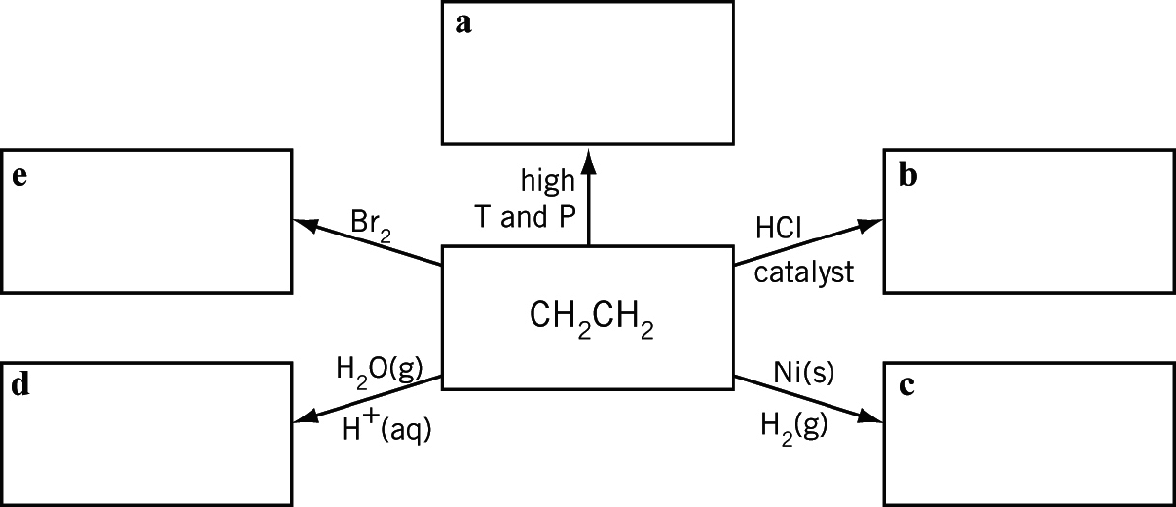

 | Draw a flowchart to summarise the production of ethene using petroleum as a raw material.

